**ML Task One Group Assignment**

**Instructions:**

1. Work in groups of up to a **maximum of 4 guys from the same group i.e. ICS-A or ICS-**

**B** (this groups to be maintained for the rest of the semester)

Click to fill group members on already created groups **For Group A:**

[**https://drive.google.com/file/d/1xwKq5GcS56SRY1W_C0SvMhzQ691KXIl/view?usp=sharing**](https://drive.google.com/file/d/1xwKq5GcS56SRY1W_C0SvMhzQ6-91KXIl/view?usp=sharing) **For Group B:**

[**https://drive.google.com/file/d/1bwMPJAxgoTBSHO4R4AyHarNwSj_wHYh6/view ?usp=sharing**](https://drive.google.com/file/d/1bwMPJAxgoTBSHO4R4AyHarNwSj_wHYh6/view?usp=sharing)

1. Have a .txt file of **group members** as part of your git files
2. Upload your notebooks on your git account then send group leaders git link to edmondmenya@gmail.com **deadline Friday 8th May** before Midnight
3. Code the python model **(Notebook on Collab)** to perform an **L2 regularized linear model** on the Nairobi Office price dataset **(5 marks)** *– show the calculations (both on paper and code) made on the loss function and its derivative*

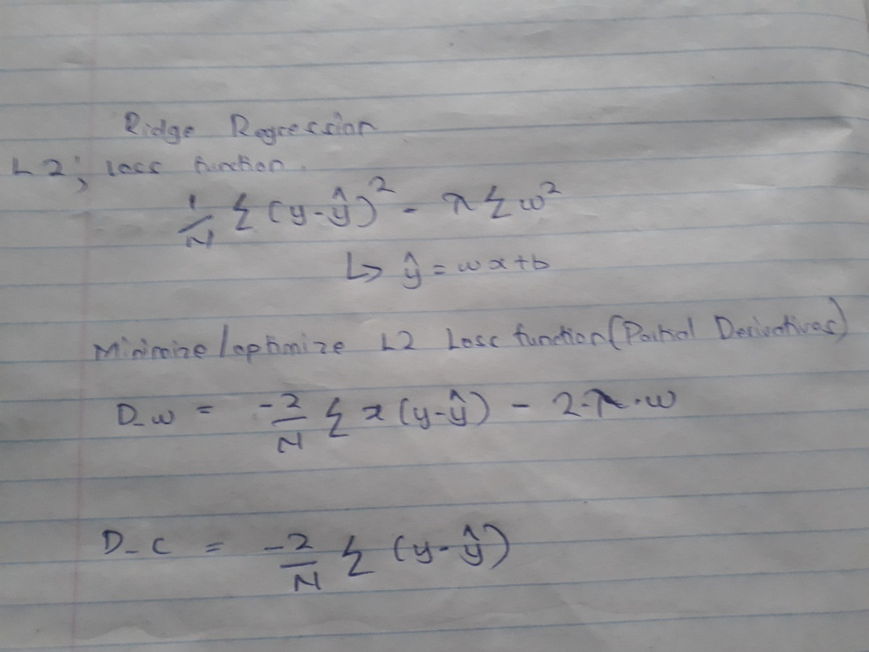

1. Code **L1 regularized linear regression model (after showing working)**. Run the model and **explain** the error that you immediately encounter. How can you avoid such an error? **(10 marks)** *- search on how to differentiate absolute functions and show this in your working*

**Division By zero error. This is so because the initial w is 0. You can have the initial w changed to a number other than 0 e.g 1.**

